**COMSATS UNVERISTY ISLAMABAD**



**Artificial Intelligence**

**Lab 2**

**Submitted by:**

Hasaan Ahmad SP22-BSE-017

**Submitted to:**

**Sir Waqas Ali**

**Task 1:**

# LAB 1 (HASAAN AHMAD SP22-BSE-017 )

list1 = []

list2 = []

for i in range(5):

    n1=int(input("Enter a Number: "))

    list1.append(n1)

for i in range(5):

    n2=int(input("Enter a Number:"))

    list2.append(n2)

for i in range(5):

    list1.append(list2[i])

list1.sort()

print(list1)

**Output:**

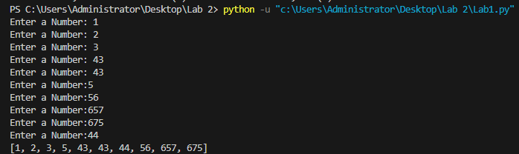

**Task 2:**

# LAB 2 (HASAAN AHMAD SP22-BSE-017 )

list1 = []

list2 = []

print("Enter values for List 1:")

for i in range(5):

    n1 = int(input("Enter a Number: "))

    list1.append(n1)

print("Enter values for List 2:")

for i in range(5):

    n2 = int(input("Enter a Number: "))

    list2.append(n2)

merged_list = list1 + list2

merged_list.sort()

print("Merged and sorted list:", merged_list)

smallest = min(merged_list)

largest = max(merged_list)

print("Smallest element:", smallest)

print("Largest element:", largest)

**Output:**

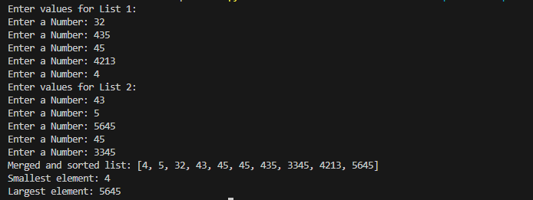

**Task 3:**

# LAB 3 (HASAAN AHMAD SP22-BSE-017 )

from math import *

h = 0.001

x_values = [i * h for i in range(int(-pi/h), int(pi/h) + 1)]

def derivative_of_sin(x, h):

    return (sin(x + h) - sin(x)) / h

for x in x_values:

    derivative = derivative_of_sin(x, h)

    actual_cos = cos(x)

    print(f"At x = {x}, Derivative of sin(x) = {derivative}, Cos(x) = {actual_cos}")

**Output:**

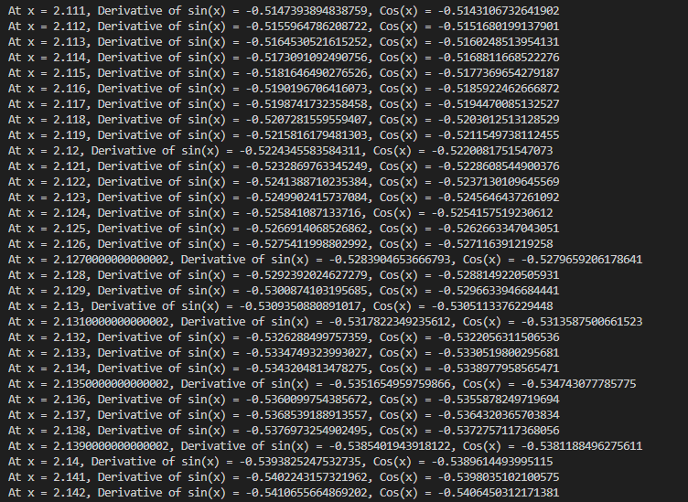

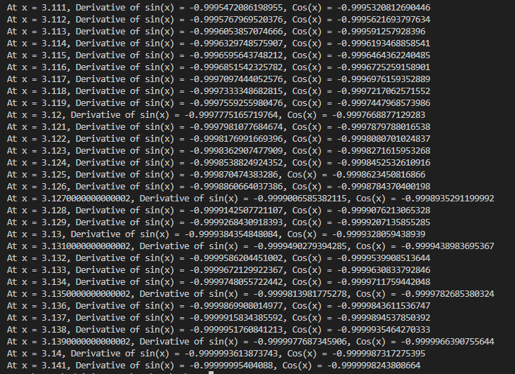

**Task 4:**

# LAB 4 (HASAAN AHMAD SP22-BSE-017 )

birthday_dict = {

    "Hasaan Ahmad": "03/14/2002",

    "Mohammad": "01/17/2010",

    "Ali": "12/10/2003"

}

print("Welcome to the birthday dictionary. We know the birthdays of:")

for name in birthday_dict:

    print(name)

name = input("Who's birthday do you want to look up?\n")

if name in birthday_dict:

    birthday = birthday_dict[name]

    print(f"{name}'s birthday is {birthday}.")

else:

    print("Sorry, we don't have birthday information for that person.")

**Output:**

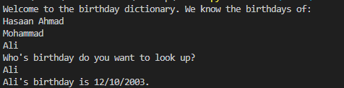

**Task 5:**

# LAB 5 (HASAAN AHMAD SP22-BSE-017 )

sample_dict = {

    "name": "Hasaan",

    "age": 21,

    "salary": 12000,

    "city": "Islamabad"

}

keys = ["name", "salary"]

new_dict = {key: sample_dict[key] for key in keys}

print(new_dict)

**Output:**

